**Task 1 Q2-**

Write a program which will find all such numbers which are divisible by 7 but are not a multiple of 5, between 2000 and 3200 (both included). The numbers obtained should be printed in a

comma-separated sequence on a single line.

**Source code-**

list=[]

for a in range(2000,3201):

if (a%7==0 and a%5!=0):

list.append(a)

count=0

length=len(list)

for b in list:

count=count+1

if(count==length):

print (b)

else:

print (b, end=",")

**Output-**

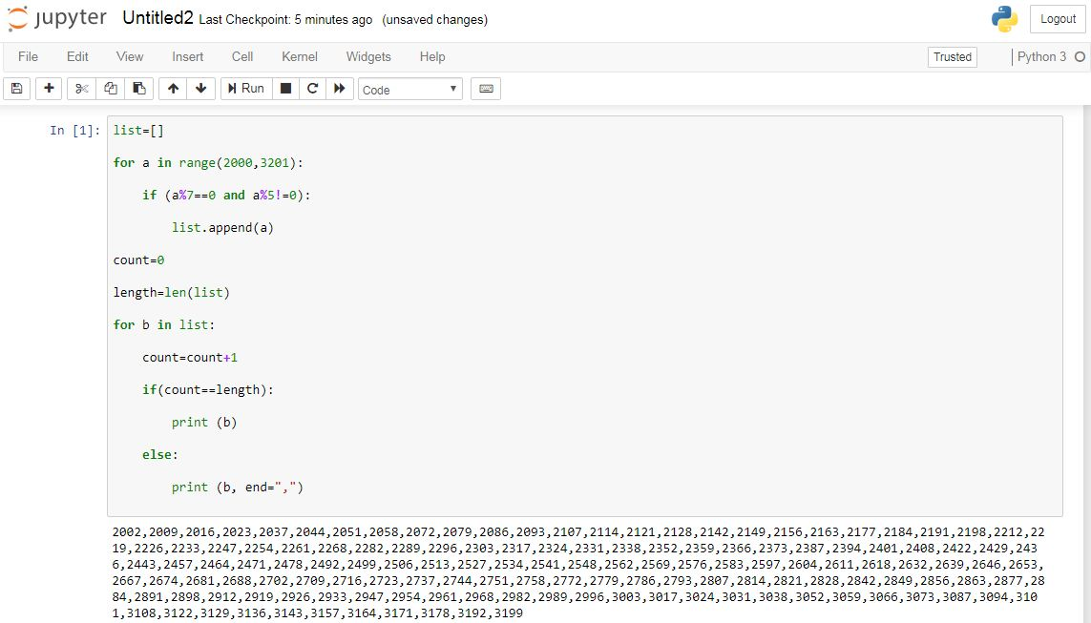

**Task 1 Q3-**

Write a Python program to accept the user's first and last name and then getting them printed in the reverse order with a space between first name and last name.

**Source code-**

**-When first name and last name are entered separately by user**

print('Enter first name')

fn= input()

print('Enter last name')

ln=input ()

print('Your reversed name is: '+ ln + " "+ fn )

**Output-**

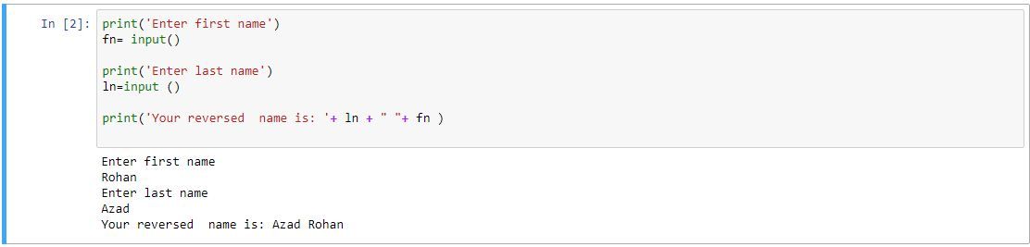

**-When first name and last name are entered together by user**

print("Enter full name with a space after first name:")

input=input()

index_space=input.index(" ")

print("Your reversed name is: " + input[index_space + 1:len(input)] + " " + input[0:index_space])

**Output-**

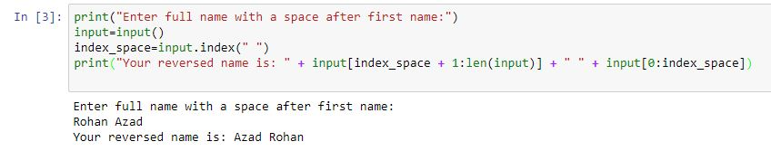

**Task 1 Q4-**

Write a Python program to find the volume of a sphere with diameter 12 cm.

Formula: V=4/3 * π * r^3

**Source code-**

import math

pi=math.pi

diameter=12

r_cube=math.pow(diameter/2,3)

volume=(4/3)*pi*r_cube

print ("Volume is", volume, "cubic cm")

**Output-**

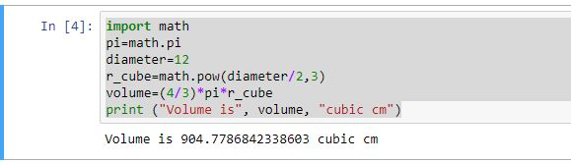

**Task 2 Q1-**

Write a program which accepts a sequence of comma-separated numbers from console and

generate a list.

**Source code-**

print("Please type numbers with comma in between")

input=input()

print("Input numbers are: " + input)

list=list(input)

length=len(list)

value=0

count=0

newlist=[]

for a in list:

count=count+1

if (a!=","):

value=(value*10)+int(a)

if (count==length):

newlist.append(value)

else:

newlist.append(value)

value=0

print(newlist)

**Output-**

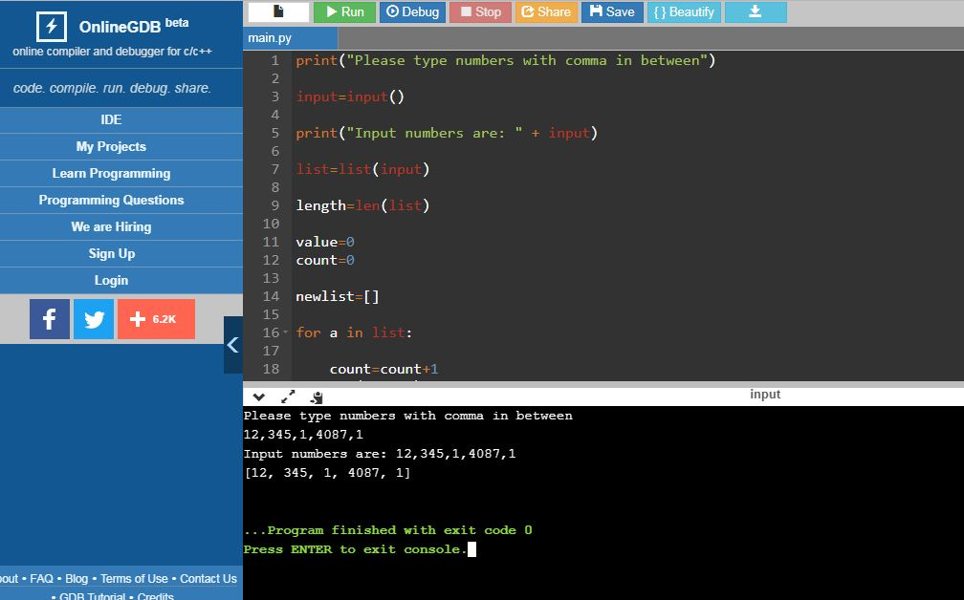

**Task 2 Q2-**

Create the below pattern using nested for loop in Python.

*

* *

* * *

* * * *

* * * * *

* * * *

* * *

* *

*

**Source code-**

**-Printing the pattern given in the question**

for a in range(1,10):

if a<=5:

for b in range(1,a+1):

print ("*", end=" ")

print("\n")

else:

for b in range(1,11-a):

print("*", end=" ")

print ("\n")

**Output-**

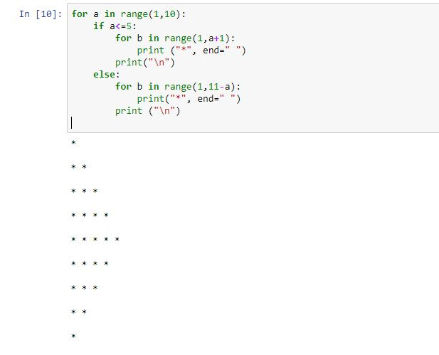

**-Printing any pattern as per user’s wish**

print('Enter the no. of rows:')

num= int(input())

for a in range(1,num+1):

if a<=(num/2)+(1/2):

for b in range(1,a+1):

print ("*", end=" ")

print("\n")

else:

for b in range(1,num-a+2):

print("*", end=" ")

print ("\n")

**Output-**

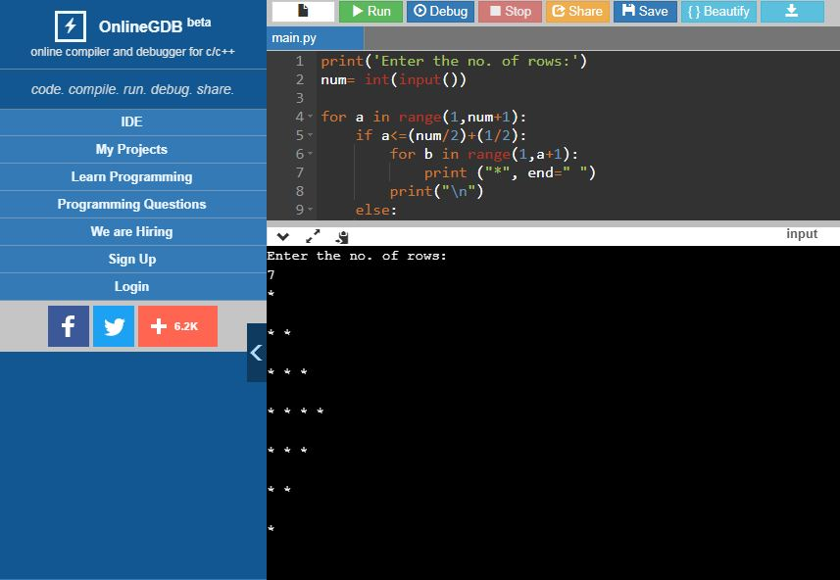

**Task 2 Q3-**

Write a Python program to reverse a word after accepting the input from the user.

**Sample Output:**

Input word: AcadGild

Output: dilGdacA

**Source code-**

print("Please type a word")

input=input()

print("Input word is: " + input)

reverse=input[::-1]

print("Reverse is : " + reverse)

**Output-**

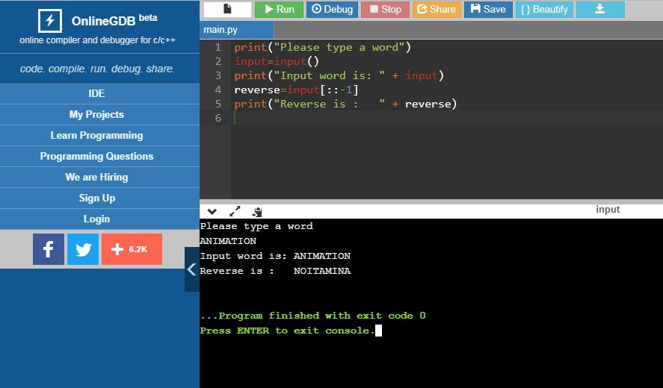

**Task 2 Q4-**

Write a Python Program to print the given string in the format specified in the **sample output.**

WE, THE PEOPLE OF INDIA, having solemnly resolved to constitute India into a

SOVEREIGN, SOCIALIST, SECULAR, DEMOCRATIC REPUBLIC and to secure to all

its citizens

**Sample Output:**

WE, THE PEOPLE OF INDIA,

having solemnly resolved to constitute India into a SOVEREIGN, !

SOCIALIST, SECULAR, DEMOCRATIC REPUBLIC

and to secure to all its citizens

**Source code-**

*Didn’t understand the question!*